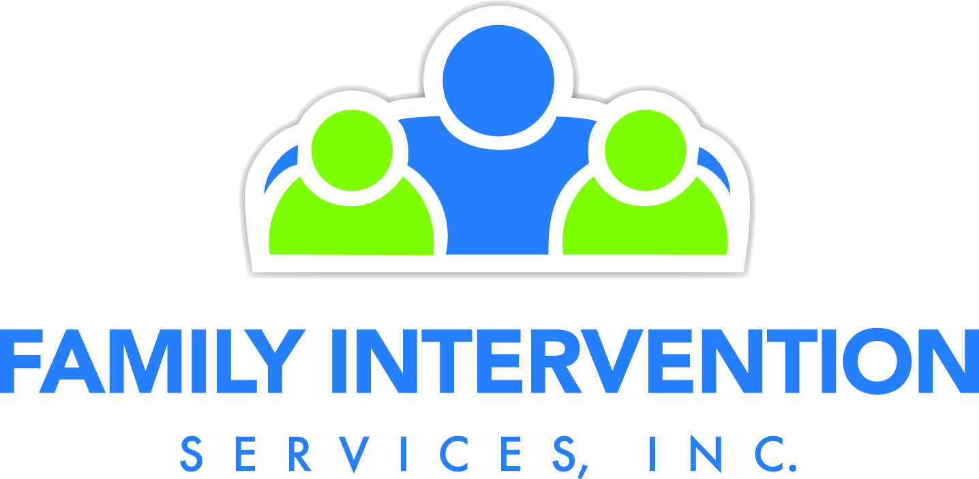

Our therapists envision the future, instill hope and demonstrate humanity while focusing on our mission of promoting the positive growth, development and well being of children, families and communities. Visit our website www.fisnj.org to learn more and get connected.

We invite you to look closely at the current programs administered through our Morris Office:

Outpatient Services:
- Family counseling provided to recipients of Medicaid
- Medication Monitoring, Management and/or psychiatric evaluation provided
- Medication Monitoring to supplement family counseling
- Availability on evenings and weekends
- Licensed therapists (including males and Spanish-speaking)
- Service available to families with children up to the age of 18
- If non-Medicaid recipients, there is a fee for service available
- Referrals: contact our Access Number for further information: 1-844-446-2299
Child Outpatient Specialist Services:
- Short-term counseling (3-6 months) for families with children up to the age of 21 by a licensed therapist
- All services available to families with Medicaid, private or no insurance
- Flexible evening availability in our Denville/Rockaway Office
- Provides services to families with children who are at risk or have had a psychiatric evaluation or hospitalization
- Referrals: contact Dahiana P. Grisales at dgrisales@fisnj.org or 973-586-5243

Family Crisis Intervention Unit (FCIU):
- Up to five months of FREE counseling for families who have children between 11 -17 years old that are not on probation and do not have a permanency case with CP&P
- All services provided by a licensed therapist in the office, home or community
- Appointment availability within 24-hours (incl. evenings)
- Provides educational support groups on-site and in the community
- Referrals: contact Dahiana P. Grisales at dgrisales@fisnj.org or any FCIU staff member at 973-586-5243

Family Outreach Program (FOP):
- Services are provided at no-cost to families that struggle to meet their basic needs
- Services are provided in the home or community for 3-6 months
- Provides counseling, education, parenting skills, advocacy & community
- 24/7 crisis support to help families restore safety, de-escalate crisis situations
- Referrals: contact Dahiana P. Grisales at dgrisales@fisnj.org or at 973-586-5243

Children’s Mobile Response & Stabilization Services (CMRSS, Mobile):
- Provides immediate in-person response to a crisis
- Connects families to counseling and/or behavioral assistance
- Refers to community services
- With family’s consent, provides support and case management services for up to 8 weeks
- Works with families who have children & youth 3 to 21 years old
- Serves children & youth who have demonstrated escalating behaviors that threaten to disrupt their current living arrangement.
- Services are provided free of charge to the family
- Dispatches can be requested by families 24/7 by calling Perform Care at 1-877-652-7624

Supervised Visitation Program (SVP):
- SVP workers provide transportation & supervised visitation for CP&P children who have been removed from their parents care
- SVP is tailored to suit the family’s needs regarding the level of direct supervision required and the location of the visits
- Visits can take place in a variety of locations, as decided by CP&P and focus on supporting the parent child relationship
- Visitations are mostly provided to families in the community
- SVP produce notes based on each supervised visit which is regularly submitted to the assigned CP&P worker
- Referrals: contact Nicole Riverso at nriverso@fisnj.org or at 973-586-5243 or RDS: Christine Rivera, Kara Vincelli

Enhanced Supervised Visitation Program (ESVP):
- Provides supervised visitation to children in foster care or who have been removed from their parents and are granted weekly visitation
- Consists of coordinated visits that provide opportunities for parent/caregiver enrichment of skills
- Visits focus on activities that support the parent/child relationship, provide the parent with opportunities to learn and practice new skills
- Visits focus on tasks including childcare, feeding and diapering babies, food preparation, supervision of meals and snacks for older children and help with homework
- At the end of each visit the staff who supervised the visit discusses behaviorally specific observations with the parent or caregiver and provides them with feedback (coaching) regarding what went well during the visit as well as areas to work on improving at future visits
- Referrals: contact Nicole Riverso at nriverso@fisnj.org or at 973-586-5243 or RDS: Christine Rivera, Kara Vincelli

Pre & Post Adoption Services (PACS):
- Provides In-home family counseling for 1 to 2 hours weekly for pre and/or post adoptive families.
- Services also include case management, advocacy, psycho-education, and Life-book work.
- 24/7 crisis support to help families restore safety, and de-escalate crisis situations.
- Referrals: contact Kalo Maloney at kmaloney@fisnj.org or at 973-586-5243; or RDS: Christine Rivera, Kara Vincelli

Family Stabilization Program (FSP):
- Traditional weekly family therapy to families who have a permanency case with CP&P
- Provides in-office or in-home family therapy for up to 12 months as long as CP&P remains open
- Family therapy sessions can be 1-2 hours long as deemed clinically appropriate/recommended
- Licensed therapists with flexible evening availability, (including Spanish-speaking and males)
- Referrals: contact Dahiana Grisales at dgrisales@fisnj.org or at 973-586-5243 or RDS: Christine Rivera, Kara Vincelli

Mending Arts
- Provides youth ages 5 -18 with creative arts therapy in a group setting
- Youth participate in groups that focus on utilizing music, dance, drama, art etc. to address mental health/behavioral health issues
- Group topics vary throughout the year (e.g. Bullying, Self-Esteem, Substance Abuse)
- Groups are held in the community (schools, libraries, community agencies, etc.) or in FIS’s office
- Length of group time varies, weekly for 1 ½ to 2 hours for up to 12 weeks
- Referrals: contact Allison Zeis at azeis@fisnj.org or at 973-586-5243

For any questions regarding any FIS Morris program or to reach our
24/7 crisis support line, please call 973-586-5243

We’re here to serve families by offering support, counseling and linkage to community resources.

